**NES Controller**

The Nintendo Entertainment System’s (NES) video game controller was selected as the input device in which the user will be able to control their respective player with. The controller uses a shift register to serially communicate which button on the controller was pressed if any. The controller requires 5 wires to operate, they are as follows:

Power: This is a 3.3 Volt wire that is used to power the controller.

Ground: This is wire is the common ground between the Nexys 3 and the controller

Data: A one wire line that is used to transmit the data from the controller.

Latch: A one wire line that sends out a 60 Hz pulse to initiate the data transfer from the controller.

Pulse: A one wire line that is used to capture the data from the controller.

The controller runs off of a 60 Hz latch pulse that initiates the shifting of the 8 bits of information that correspond to the 8 buttons on the controller. The latch pulse lasts for 12 μs, once completed the data for button A is captured on the negative edge of the latch. 6 μs later the pulse line gets pulled low, and begins to toggle ever 6 μs. Each time the pulse line is pulled low, the data corresponding to each button is latched within an output register. Once the data transfer is complete, the pulse line is set high until the process repeats. The following figure displays the timing diagram used for the NES controller.



The buttons on the controller are active low, therefore if a button has been pressed its corresponding bit will be 0 when it is shifted out, else it will be a 1. In the code however when the information is latched from the controller it is inverted to make the code clearer to implement.

The controller logic was implemented using an implicit finite state machine based on the count that was used to control the output’s based upon a counter because the Nexys 3 runs off of a 100 MHz clock, the counter was necessary to be able to control the timing requirements needed for successful operation. If a reset is encountered, the count is reset to 0, and the latch and pulse lines are set to low and high respectively. The counter counts from 0 to 1666667 which gives the latch pulse the ability to occur at a 60 Hz rate. Important counts for the latch and pulse lines are in the following ranges:

0-1200: In this range the latch pulse will be high, this range gives the latch’s duration of 12 μs. After the count reaches 1200 the latch line is pulled low, and is kept low until the counter resets.

1800: At this point the pulse line begins to toggle every 6 μs, each time the pulse line is pulled low, data is captured.

10201-1666667: In this range the pulse line is pulled high, and the latch line is kept low as required once the data transfer is complete.

Important count ranges for the data capture are as follows:

1200-1800: The data for button A is captured and stored in the 7th position in the array containing the information about which button had been pressed

2400-3000: The data for button B is captured and stored in the 6th position in the array containing the information about which button had been pressed

3600-4200: The data for button SELECT is captured and stored in the 55h position in the array containing the information about which button had been pressed

4800-5400: The data for button START is captured and stored in the 4th position in the array containing the information about which button had been pressed

6000-6600: The data for button UP on the D-pad is captured and stored in the 3rd position in the array containing the information about which button had been pressed

7200-7800: The data for button DOWN on the D-pad is captured and stored in the 2nd position in the array containing the information about which button had been pressed

8400-9000: The data for button LEFT on the D-pad is captured and stored in the 1st position in the array containing the information about which button had been pressed

9600-10200: The data for button RIGHT on the D-pad is captured and stored in the 0th position in the array containing the information about which button had been pressed

Waveforms:

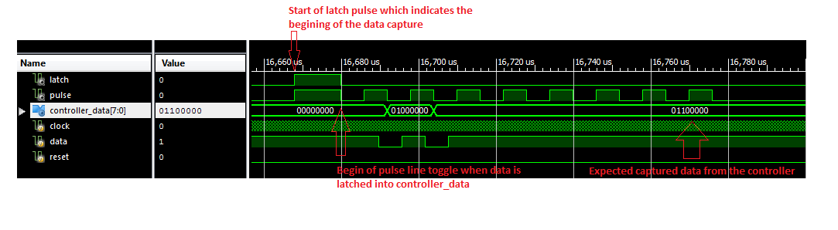

Figure : Captured Waveform from the Test Bench Simulation for the NES Controller.